Second Sight

2009

SMARTBELT

*Obstacle Detection Device for the Visually Impaired*

Carlos Bautista | Steven Rodriguez

Smartbelt Patent Proposal

Second Sight | Bautista : Rodriguez

Contents

Contact Information 2

Abstract 3

Introduction 3

Benefits for Target Audience 3

System Comparisons | Smartbelt Features 4

Design Specifications 5

LV-MaxSonar 6

ATMEGA32 6

16-1 CD74HC4067 Multiplexer 7

Algorithm Design 7

# Contact Information

Carlos Bautista Steven Rodriguez

[cbautista1002@gmail.com](mailto:cbautista1002@gmail.com) [srodriguez511@gmail.com](mailto:srodriguez511@gmail.com)

646 – 267 – 4763 347 – 403 – 6677

# Abstract

The Smartbelt is designed to provide a greater degree of mobility for the visually impaired. It is a hands-free, wearable device which detects obstacles around the user. Through the use of ultrasonic signals, the sensors on the Smartbelt can determine if there are obstacles nearby in three dimensions and provide the appropriate vibration feedback to the user. Integrated circuits are used throughout the system to control the sensors, interpret their readings, and provide proper vibrations.

# Introduction

Considering the fact that sight is just one of a human’s five senses, it is pretty astonishing to think that a huge percentage, 80 to 90 percent, of the information we assimilate from the world around us is gathered through sight. Even human to human communication is based more on sight and body language than on voice and words. With this in mind, it may be difficult to understand how it is to live without sight. One’s ability to communicate, navigate, learn, etc. is greatly affected when sight is not available.

Advances in assistive technology for the visually impaired have been plentiful in certain areas while few and far between in other areas. For example, a visually impaired person’s ability to take in information has been greatly improved through brail, audio and advances in computer software. But their ability to navigate through dense indoor and outdoor environments is still limited to the “White Cane” or guide dogs. A hands-free, wearable and technologically advanced device appropriate for the 21st Century is overdue.

The Smartbelt is a design that expands on the already existing assistive methods designed for the visually impaired. Similar to the “White Cane”, the Smartbelt’s goal is to provide the user with the ability to detect objects within their path.

# Benefits for Target Audience

There are 20 million Americans who are documented as having experienced exceptional vision loss. Nearly one million of those are legally blind, ten percent of which have absolutely no vision. This is an unfortunately large number, in any regard. The Smartbelt can improve the everyday life of these individuals.

A human’s ability to safely navigate is highly dependent on sight. Any device that can aid in this process performs a critical function. The Smartbelt cannot substitute sight but it can emulate one important detail that sight provides us with – obstacle detection. Being able to detect where an obstacle is, relative to the user, increases a visually impaired person’s ability to navigate safely. It performs this all while not overwhelming any other sense. The second most important sense to an individual, who is visually impaired, hearing, is left unaffected letting the user employ their ears for other important notifications. Also, because the device is wearable it leaves the user with the ability to use their hands freely.

Although the visually impaired are currently used to other methods of obstacle detection, they can easily learn to use the Smartbelt. After training with the Smartbelt, sensing and interpreting the vibrations can become second nature.

# System Comparisons | Smartbelt Features

Currently the favored methods of obstacle detection are walking sticks and guide dogs. These methods pose several issues and concerns.

* Walking sticks mainly detect obstacles that lay on the ground leaving the user the task of figuring out the height of the object.
* Walking sticks also occupy one of the user’s hands – a highly unfavorable characteristic when trying to navigate.
* Walking sticks may accidently hit other people while the user it trying to navigate.
* Walking sticks have a limited range – their length depends on the user’s height although longer sticks may be used. Their range is still limited to just a couple of feet.
* Walking sticks may be difficult to store in public environments, especially if they’re not foldable/collapsible.
* Walking sticks require a constant back and forth waving motion. Although the user can get used to this, they can still become physically tired – especially those with further physical disabilities or the very young and elderly.
* Walking sticks are a highly visible symbol of blindness. Although this is usually a positive characteristic, under certain conditions a visually impaired person may not want to be identified as such.
* Guide dogs require lots of maintenance. Like any other pet, they must be fed and looked after.
* Guide dogs are not a suitable option for those with allergies.

The Smartbelt does away with many of these issues, all while providing the aforementioned benefits (previous section).

* Smartbelts detect obstacles in three dimensions, up to 21 feet, without occupying the user’s hands.
* Smartbelts are small and are worn directly on the body without ever affecting any nearby pedestrians. Its small form factor makes it very discrete and unnoticeable.
* Smartbelts do not require constant user intervention for proper operation allowing the user to concentrate on other activities. This also saves the user energy expenditure.
* Smartbelts need not be taken off when not in use. They can simply be turned off.
* Smartbelts are virtually maintenance free. The only requirement is that the battery needs to be recharged / replaced.
* Smartbelts are highly scalable, configurable and customizable providing the opportunity for several price points.
  + Many sensors can be placed onto the Smartbelt: as little as one sensor or as many as the belt can hold.
  + Potential user can have the option of selecting different configurations. This allows for the user to only pay for what they need.
  + As the Smartbelt is worn on the body, it can become a fashion statement. Different materials and textures can be used for the belt allowing the user to display their personal taste.

# Design Specifications

The Smartbelt system consists of ultrasonic sonar sensors, vibration motors, an ATMEGA32 microcontroller, a MAX232 converter and a 16:1 multiplexer. The ATMEGA32 is the controlling unit and receives serial transmission from the sensors. The sensors use the RS232 serial protocol and the ATMEGA32 uses the USART serial protocol. Due to this incompatibility, a MAX232 is used to convert the different voltage levels. However, the ATMEGA32 is only capable of receiving a single serial transmission at a time. Therefore a multiplexer is used to alternate between the sensors, reading one sensor at a time. This can be adjusted and up to 16 sensors can be used per multiplexer. As a source of notification to the user, when any obstacle is detected within a range encoded onto the ATMEGA32, a vibrator alerts the user of the upcoming obstacle. These vibrators are placed next to each sensor which allows the user to have a pinpoint feedback as to where the object is located.

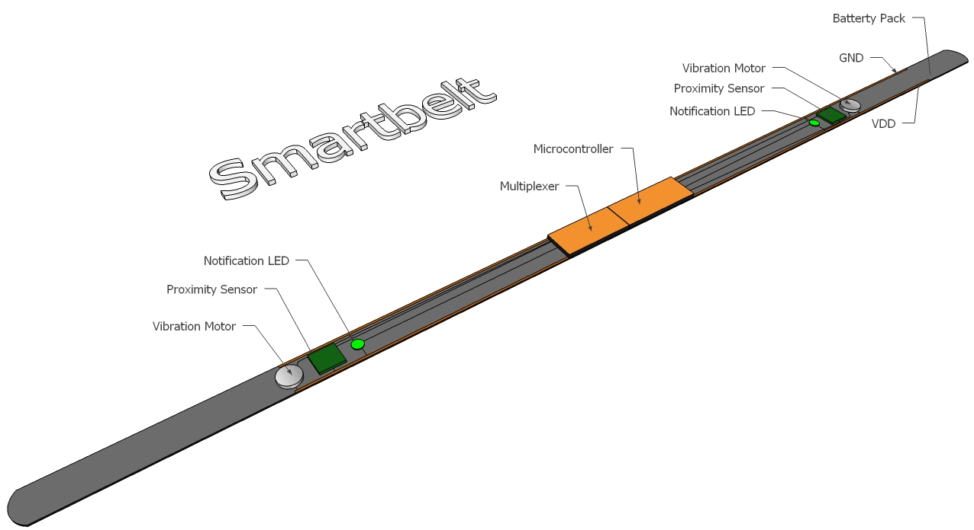

Figure : Smartbelt Diagram

## LV-MaxSonar

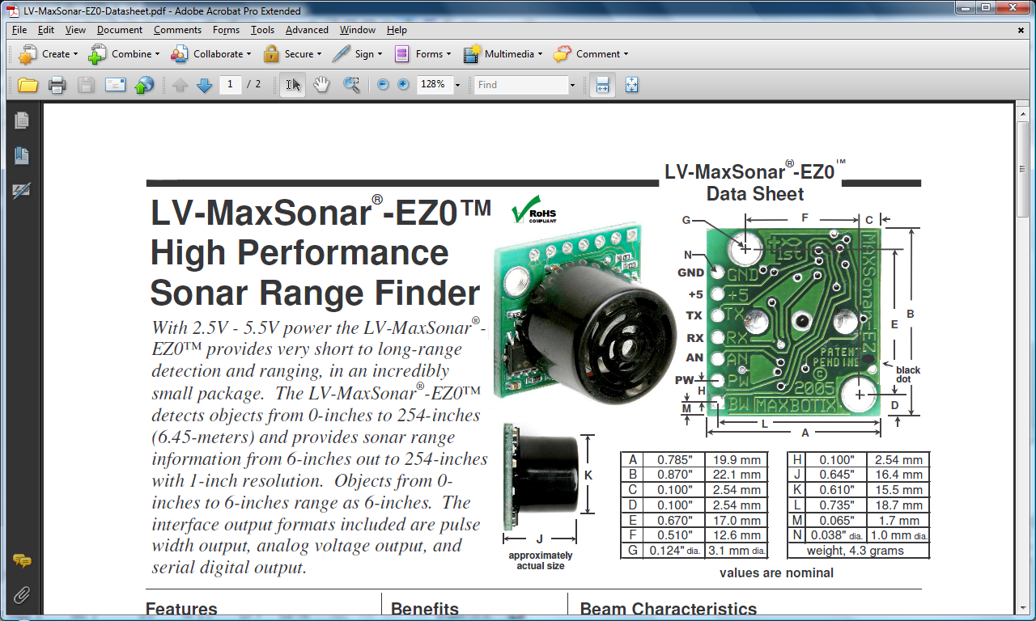

The MaxSonar detects an object’s distance using ultrasonic sonar waves and outputs the distance in three different modes simultaneously: Analog Voltage, Pulse Width, and Serial Transmission/Receive. As can be seen here there are three necessary pins for our design, GND, VDD (2.5 – 5.5 V), and TX. The mode of serial operation is RS232. The sensor will output in serial mode, ASCII R followed by 3 successive ASCII bits from 0 – 255, representing the range in inches the object is from the sensor and finally a carriage return. It operates at 9600 bps.

Figure : Maxbotix LV MaxSonar Diagram

## ATMEGA32

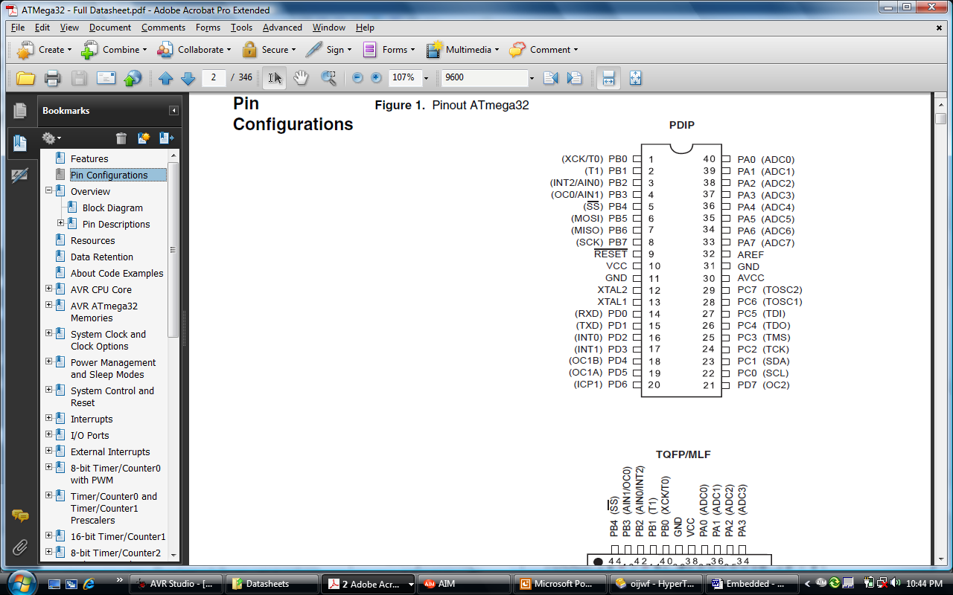The ATMEGA32 has a USART – Universal Synchronous Asynchronous Receive Transmission. It is a type of serial protocol that works in a smaller voltage range than RS232. This made it necessary to use a MAX232 chip which will translate the USART to RS232 voltage levels and vice versa. By default, the ATMEGA32 ships with an internal frequency of 1MHZ. At these frequencies, 9600 bps serial communication has an error rate of 7% which is too high to properly communicate with the device. Therefore it was necessary to change the internal frequency to 8MHZ where 9600bps has a .2% error rate. This was done by changing CKSEL fuse bits to 0100 using AVR Studio. The UBBR register handles the baud rate. UCSRA, UCSRB, and UCSRC are the USART registers. A and B are mostly status while C is the control register. However, it shares the same I/O address as UBBR. If UCSEL is set to 0, the UBBR register is changed and if set to 1 UCSRC can be changed. UCSRB contains the TX and RX enable bits and UCSRC contains the bits responsible for setting transmission to 8 bits with 1 stop bit and no parity. Port B on the ATMEGA32 was set to act as an output which releases 5 volts in each pin. These pins are where the vibrators and the select lines to the multiplexer are connected.

Figure : Atmel AVR ATMEGA32 Pinout

## 16-1 CD74HC4067 Multiplexer

The multiplexer is capable of channeling serial signals. Pin 1, is the output, which is the result of choosing which signal the program will check from the sensors. The enable bit, pin 15, is active low and it is grounded. Pins 10, 11, 14 and 13 represent S0, S1, S2 and S3 respectively. The two sensors are connected to I1 and I3. The code is designed to alternate between the two sensors by counting to a certain number and setting the select signals of I1 and I3 at different times.

Figure : Texas Instruments

16-1 Multiplexer Pinout

## Algorithm Design

The algorithm design for the Smartbelt is simple and efficient. The appropriate registers and setup modes for the ATMEGA are activated first. An internal counter is used to alternate between the sensors on the system. This can easily be altered as the ATMEGA is reprogrammable. Choosing the right amount of time for each sensor to be active is critical and through proper calibration this number can be correctly determined.

Data is received until an “R” character is sent by the sensor. Once the program receives this signal, it knows the next 3 characters represent the range and therefore it will continue to receive 3 more characters. If needed, this value is also transmitted out from the ATMEGA for debugging purposes and can be seen on any serial interface such as HyperTerminal. Finally, the pre-defined range detection system takes the number it received and checks if it is within the ‘danger’ zone. When an object is within the danger zone, the appropriate vibrator is activated.